SIMATS ENGINEERING
ASSESSMENT TOOL 3: Modelling Comparative Analysis Assignment
COURSE NAME: | ARTIFICIAL INTELLIGENCE AND EXPERT SYSTEMS | COURSE CODE: | MLA01

COURSE OUTCOME COVERED
CO 5: Construct rule-based expert systems using production rules, forward and backward chaining, and by distinguishing procedural and non-procedural paradigms across development stages.(BTL 3)
Assessment Tool Weightage: 40%
Total Marks: 100 Time: 90 Mins
No. of Questions: 1
Annexure A
Modelling Comparative Analysis Assignment

Code of Conduct:
I Mokshitha Kilari (192525413) (Name / Reg No) certify that this submission is my original work and that I have adhered to the guidelines specified for this assessment.
I understand that any violation of academic integrity rules will result in disciplinary action.
Signature of the student: MOKSHITHAKILARI
Criterion | Weightage (%) | Marks Obtained
1. Problem Analysis and Domain Understanding | 10%
2. Domain Knowledge and Fact Identification | 10%
3. Production Rule Modelling | 15%
4. Propositional Logic Modelling | 10%
5. First-Order Logic Modelling | 15%
6. Prolog Modelling and Implementation | 15%
7. Forward and Backward Chaining Demonstration | 10%
8. Comparative Analysis of Modelling Approaches | 10%
9. Results, Discussion and Model Selection | 3%
10. Documentation, GitHub Repository and Presentation | 2%
Total | 100%

Signature of the Faculty Total Marks Awarded
ANSWER ANY ONE OF THE FOLLOWING

S.No. | Question / Problem Statement
1 | Automobile Fault Diagnosis:  An automobile service center wants to identify vehicle faults based on symptoms such as engine overheating, starting failure, abnormal noise, low mileage, and warning indicators. Model the problem using production rules, propositional logic, first-order logic, and Prolog. Demonstrate forward and backward chaining and compare the approaches based on expressiveness, inference, complexity, and suitability.
2 | Industrial Machine Fault Diagnosis:  A manufacturing plant needs to identify machine faults using observations such as abnormal vibration, high temperature, unusual noise, pressure variation, and reduced production speed. Develop different knowledge representation models and compare their ability to represent machine components, relationships, rules, and diagnostic conclusions.
3 | Cybersecurity Threat Detection:  A security operations center wants to identify threats from repeated login failures, unusual login locations, privilege escalation, suspicious file access, and abnormal network traffic. Model the threat-detection problem using production rules, propositional logic, first-order logic, and Prolog, and compare forward and backward reasoning for deriving security conclusions.
4 | Healthcare Diagnosis:  A healthcare system needs to identify possible diseases from symptoms such as fever, cough, fatigue, breathing difficulty, and body pain. Construct comparative knowledge models using production rules, propositional logic, first-order logic, and Prolog. Analyze which representation provides better expressiveness and reasoning capability for diagnosis.
5 | Agricultural Crop Disease Diagnosis:  Farmers need assistance in identifying crop diseases based on leaf color, spots, wilting, soil conditions, humidity, and pest observations. Represent the agricultural knowledge using different modelling approaches and compare their effectiveness in representing relationships, applying rules, and deriving recommendations.
6 | Banking Loan Eligibility:  A bank wants to determine loan eligibility using income, credit score, employment status, existing loans, and repayment history. Model the decision-making process using production rules, propositional logic, first-order logic, and Prolog, and compare the reasoning capabilities of each approach.
Structure of the Report:

S.No. | Report Section | Expected Content
1 | Problem Statement & Objectives | Describe the selected real-world problem, domain, decision-making requirement, and objectives of the modelling exercise.
2 | Domain Knowledge & Facts | Identify entities, attributes, facts, relationships, conditions, and conclusions relevant to the selected problem.
3 | Production Rule Model | Represent the domain using IF–THEN production rules and explain how the rules derive conclusions.
4 | Propositional Logic Model | Represent the same problem using propositions, logical connectives, and suitable inference statements.
5 | First-Order Logic Model | Represent entities, relationships, properties, and rules using predicates and quantifiers.
6 | Prolog Model & Implementation | Convert the knowledge into Prolog facts, rules, predicates, and queries. Include relevant code and outputs.
7 | Forward & Backward Chaining | Demonstrate both reasoning mechanisms using selected facts/goals and provide the inference sequence.
8 | Comparative Analysis  (Table structure given) | Compare the models based on expressiveness, inference mechanism, complexity, scalability, flexibility, explainability, and suitability.
9 | Results, Discussion & Recommended Model | Analyze the results and justify which approach is most appropriate for the selected real-world problem. Discuss limitations and possible improvements.
10 | Conclusion, References & GitHub | Summarize findings, provide references, and include the GitHub repository link containing Prolog code, models, test cases, and supporting materials.

1. Problem Statement & Objectives
Selected problem: Cybersecurity Threat Detection. A Security Operations Center wants to identify threats from repeated login failures, unusual login locations, privilege escalation, suspicious file access, and abnormal network traffic. The assignment requires the problem to be modelled using production rules, propositional logic, first-order logic and Prolog, and to compare forward and backward reasoning.
Decision requirement: convert observable security indicators into explainable threat conclusions and defensive recommendations. The model is a decision-support prototype, not an autonomous security-control system.
- Define the domain, entities, observations and conclusions.
- Represent the same knowledge consistently in four approaches.
- Develop accurate IF–THEN production rules.
- Construct propositional and first-order logic models.
- Implement the knowledge in Prolog with queries and outputs.
- Demonstrate forward and backward chaining.
- Compare the approaches using all required evaluation parameters.

2. Domain Knowledge & Facts
The five observations named in the question are treated as base facts. Threat hypotheses are derived from combinations of these observations, and defensive actions are derived from threat hypotheses.
Concept | Fact / attribute | Relationship | Derived conclusion
Authentication | Repeated failed logins | with unusual location | Credential attack
Account | Unusual location + privilege escalation | combined evidence | Account compromise
File access | Suspicious file access + unusual location | combined evidence | Unauthorized access
Network | Abnormal traffic + suspicious file access | combined evidence | Network intrusion
Incident | Account compromise + network intrusion | combined high-risk evidence | High-priority incident
Main case facts: all five indicators are true for incident_001. This permits a complete inference chain and lets the same knowledge be tested in each modelling approach.
Domain constraints: indicators are simplified to yes/no values; the rules express decision-support patterns rather than proof of malicious activity; real SOC systems would add timestamps, event frequency, asset criticality, identity context and confidence.

3. Production Rule Model
Production rules provide the most direct operational representation because each rule states a condition and its resulting conclusion.

Rule | IF condition | THEN conclusion
R1 | IF repeated_failed_logins AND unusual_login_location | THEN credential_attack
R2 | IF unusual_login_location AND privilege_escalation | THEN account_compromise
R3 | IF suspicious_file_access AND unusual_login_location | THEN unauthorized_access
R4 | IF abnormal_network_traffic AND suspicious_file_access | THEN network_intrusion
R5 | IF account_compromise AND network_intrusion | THEN high_priority_incident
R6 | IF credential_attack | THEN mfa_reset
R7 | IF account_compromise | THEN contain_account
R8 | IF network_intrusion | THEN isolate_endpoint
R9 | IF unauthorized_access | THEN preserve_logs
R10 | IF high_priority_incident | THEN escalate_to_soc_lead
Main-case derivation: R1–R4 derive four primary threat hypotheses; R5 combines account compromise and network intrusion into a high-priority incident; R6–R10 derive the corresponding defensive actions.

4. Propositional Logic Model
For one fixed incident, the domain can be represented with Boolean propositions:
- F = repeated failed logins
- L = unusual login location
- P = privilege escalation
- S = suspicious file access
- N = abnormal network traffic
- C = credential attack
- A = account compromise
- U = unauthorized access
- I = network intrusion
- H = high-priority incident
F ∧ L → C
L ∧ P → A
S ∧ L → U
N ∧ S → I
A ∧ I → H
C → MFA_Reset
A → Contain_Account
I → Isolate_Endpoint
U → Preserve_Logs
H → Escalate_to_SOC_Lead
With F, L, P, S and N all true, the model derives C, A, U and I; A ∧ I derives H; and H derives escalation. Propositional logic is precise for a fixed Boolean vocabulary, but it does not naturally generalize across arbitrary incidents, users or endpoints.

5. First-Order Logic Model
First-order logic uses predicates and variables so that the same rule can apply to every incident entity.
∀x [(FailedLogin(x) ∧ UnusualLocation(x)) → CredentialAttack(x)]
∀x [(UnusualLocation(x) ∧ PrivilegeEscalation(x)) → AccountCompromise(x)]
∀x [(SuspiciousFileAccess(x) ∧ UnusualLocation(x)) → UnauthorizedAccess(x)]
∀x [(AbnormalNetworkTraffic(x) ∧ SuspiciousFileAccess(x)) → NetworkIntrusion(x)]
∀x [(AccountCompromise(x) ∧ NetworkIntrusion(x)) → HighPriority(x)]
∀x [CredentialAttack(x) → MFAReset(x)]
∀x [AccountCompromise(x) → ContainAccount(x)]
∀x [NetworkIntrusion(x) → IsolateEndpoint(x)]
∀x [UnauthorizedAccess(x) → PreserveLogs(x)]
∀x [HighPriority(x) → EscalateToSOCLead(x)]
Example facts: FailedLogin(incident_001), UnusualLocation(incident_001), PrivilegeEscalation(incident_001), SuspiciousFileAccess(incident_001), AbnormalNetworkTraffic(incident_001). FOL is more expressive than propositional logic because predicates, variables and quantifiers support reusable knowledge about multiple entities.
This satisfies the rubric requirement for entities, relationships, properties, variables, predicates and quantifiers with valid FOL statements. fileciteturn2file0L245-L257

6. Prolog Model & Implementation
The Prolog model translates the domain into executable facts, predicates, rules and queries. It also includes an explicit forward-chaining engine so that both reasoning mechanisms can be demonstrated in the same implementation.
% CO5-AT3 Cybersecurity Threat Detection Expert System
:- dynamic known/1.

% Facts
event(incident_001, yes, yes, yes, yes, yes).

% Predicates
repeated_failed_logins(ID) :- event(ID, yes, _, _, _, _).
unusual_login_location(ID) :- event(ID, _, yes, _, _, _).
privilege_escalation(ID) :- event(ID, _, _, yes, _, _).
suspicious_file_access(ID) :- event(ID, _, _, _, yes, _).
abnormal_network_traffic(ID) :- event(ID, _, _, _, _, yes).

% Production rules
threat(credential_attack(ID)) :-
repeated_failed_logins(ID), unusual_login_location(ID).
threat(account_compromise(ID)) :-
unusual_login_location(ID), privilege_escalation(ID).
threat(unauthorized_access(ID)) :-
suspicious_file_access(ID), unusual_login_location(ID).
threat(network_intrusion(ID)) :-
abnormal_network_traffic(ID), suspicious_file_access(ID).
threat(high_priority_incident(ID)) :-
threat(account_compromise(ID)), threat(network_intrusion(ID)).

action(mfa_reset(ID)) :- threat(credential_attack(ID)).
action(contain_account(ID)) :- threat(account_compromise(ID)).
action(isolate_endpoint(ID)) :- threat(network_intrusion(ID)).
action(preserve_logs(ID)) :- threat(unauthorized_access(ID)).
action(escalate_to_soc_lead(ID)) :- threat(high_priority_incident(ID)).

% Explicit forward chaining
forward_chain :-
retractall(known(_)),
assert_initial_facts,
forward_round,
findall(X, known(X), Raw),
sort(Raw, Conclusions),
writeln('FORWARD CHAINING RESULTS:'),
forall(member(C, Conclusions), format(' -> ~w~n',[C])).

assert_initial_facts :-
event(ID,F,L,P,S,N),
assertz(known(event(ID,F,L,P,S,N))),
(F==yes -> assertz(known(repeated_failed_logins(ID))) ; true),
(L==yes -> assertz(known(unusual_login_location(ID))) ; true),
(P==yes -> assertz(known(privilege_escalation(ID))) ; true),
(S==yes -> assertz(known(suspicious_file_access(ID))) ; true),
(N==yes -> assertz(known(abnormal_network_traffic(ID))) ; true).

forward_round :-
derive_new_facts(New),
(New=[] -> true ; add_new_facts(New), forward_round).

derive_new_facts(New) :-
findall(F, forward_rule(F), Candidates),
sort(Candidates, Unique),
findall(F,(member(F,Unique),\+ known(F)),New).

forward_rule(credential_attack(ID)) :-
known(repeated_failed_logins(ID)), known(unusual_login_location(ID)).
forward_rule(account_compromise(ID)) :-
known(unusual_login_location(ID)), known(privilege_escalation(ID)).
forward_rule(unauthorized_access(ID)) :-
known(suspicious_file_access(ID)), known(unusual_login_location(ID)).
forward_rule(network_intrusion(ID)) :-
known(abnormal_network_traffic(ID)), known(suspicious_file_access(ID)).
forward_rule(high_priority_incident(ID)) :-
known(account_compromise(ID)), known(network_intrusion(ID)).
forward_rule(mfa_reset(ID)) :- known(credential_attack(ID)).
forward_rule(contain_account(ID)) :- known(account_compromise(ID)).
forward_rule(isolate_endpoint(ID)) :- known(network_intrusion(ID)).
forward_rule(preserve_logs(ID)) :- known(unauthorized_access(ID)).
forward_rule(escalate_to_soc_lead(ID)) :- known(high_priority_incident(ID)).

add_new_facts([]).
add_new_facts([F|T]) :- assertz(known(F)), add_new_facts(T).

% Backward chaining demonstration
backward_diagnosis :-
writeln('BACKWARD CHAINING TRACE:'),
( threat(high_priority_incident(incident_001)) ->
writeln(' Goal high_priority_incident(incident_001) -> YES'),
writeln(' Need account_compromise AND network_intrusion'),
writeln(' account_compromise -> unusual_location AND privilege_escalation'),
writeln(' network_intrusion -> abnormal_traffic AND suspicious_file_access')
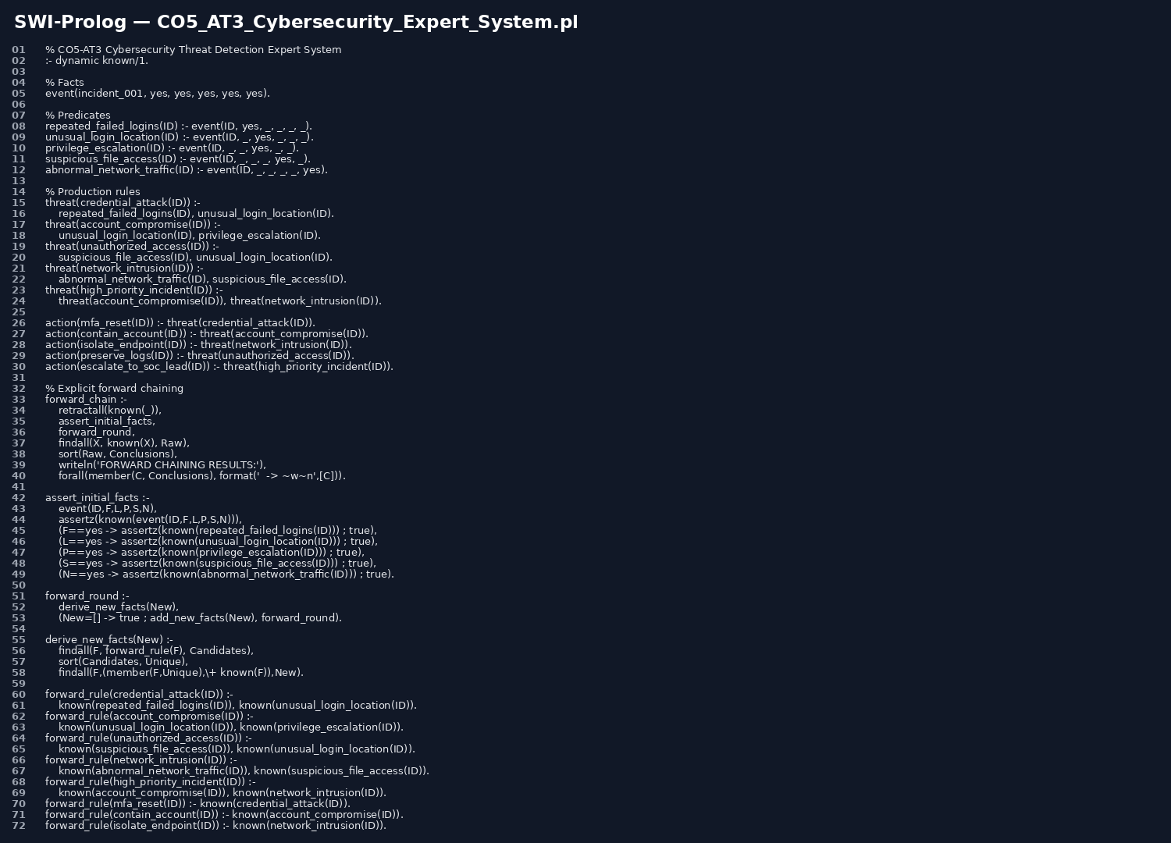
Figure 1: Prolog implementation screenshot.
Useful queries: ?- show_assessment. ?- forward_chain. ?- backward_diagnosis. ?- threat(X). ?- action(X).
The assignment requires the Prolog section to include facts, rules, predicates, queries and relevant code and outputs. fileciteturn2file0L90-L93

7. Forward & Backward Chaining

7.1 Forward chaining
Forward chaining is data-driven: begin with the known observations, repeatedly fire rules whose premises are satisfied, add new facts, and stop when no new facts can be produced.
- Start with F, L, P, S and N.
- F ∧ L → credential_attack.
- L ∧ P → account_compromise.
- S ∧ L → unauthorized_access.
- N ∧ S → network_intrusion.
- account_compromise ∧ network_intrusion → high_priority_incident.
- Derive MFA reset, account containment, endpoint isolation, log preservation and SOC-lead escalation.

7.2 Backward chaining
Backward chaining is goal-driven. Starting from high_priority_incident(incident_001), the system finds the rule that concludes it and attempts to prove its prerequisites.
Goal: HighPriority(incident_001)
<- AccountCompromise(incident_001) AND NetworkIntrusion(incident_001)
<- UnusualLocation(incident_001) AND PrivilegeEscalation(incident_001)
<- AbnormalNetworkTraffic(incident_001) AND SuspiciousFileAccess(incident_001)
All required facts are present -> YES
The assessment rubric explicitly requires both mechanisms with correct inference sequences and conclusions. fileciteturn2file0L303-L314
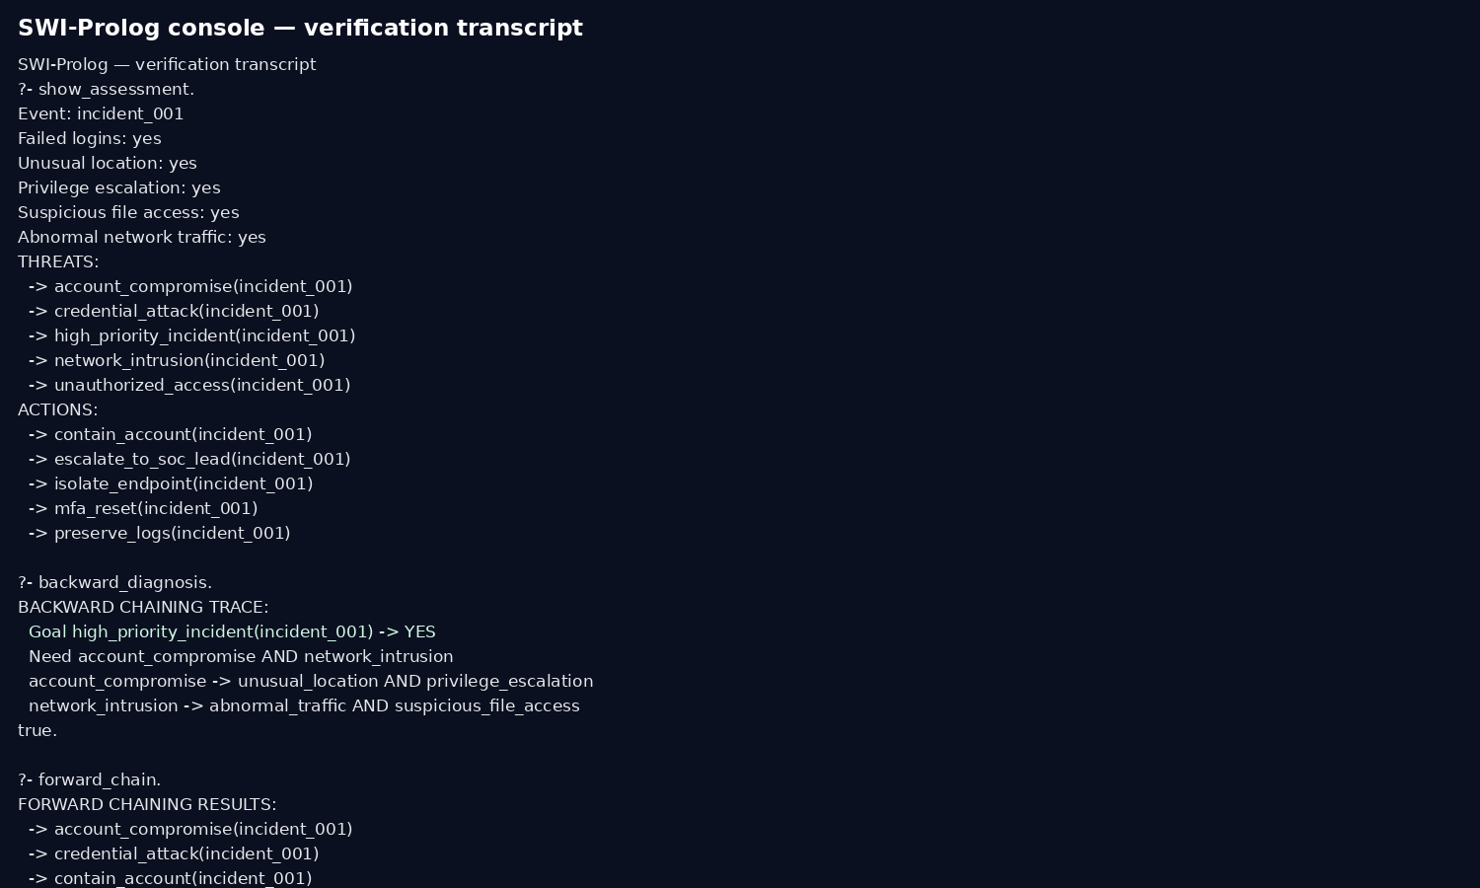
Figure 2: Prolog verification transcript.
Execution-evidence note: this transcript is provided as report evidence. For strict faculty verification, run the supplied .pl file in SWI-Prolog and replace the image with a live terminal screenshot.

8. Comparative Analysis of Modelling Approaches
The following table follows the compulsory comparison parameters specified in the assessment. fileciteturn2file0L114-L138
Parameter | Production Rules | Propositional Logic | First-Order Logic | Prolog
Knowledge Representation | IF–THEN rules | Boolean propositions | Predicates, variables, quantifiers | Facts, rules, predicates, queries
Expressiveness | Medium | Low–medium | High | High for executable rule systems
Rule Representation | Direct | Implications | Logical formulas | Declarative clauses
Inference Mechanism | Rule firing | Entailment | Logical inference | Unification, search, backtracking
Forward Chaining | Natural | Can be simulated | Possible | Explicitly implemented
Backward Chaining | Less natural | Not inherent | Goal reasoning possible | Natural query-driven search
Handling Relationships | Limited | Weak | Strong | Strong with predicates/variables
Scalability | Moderate rule sets | Poor as variables grow | Potentially high but reasoning can be complex | Good for structured rule bases
Explainability | Very high | High | High | Very high with proof/query traces
Ease of Implementation | Easy | Easy for fixed cases | Moderate | Moderate
Suitability for SOC | Good | Limited | Very good | Excellent practical prototype
Interpretation: production rules are the clearest communication format; propositional logic is compact for a small fixed Boolean problem; FOL provides the richest formal representation of entities and relationships; Prolog combines declarative rules with executable inference, making it the strongest practical choice for this assignment's working expert-system requirement.
The comparison explicitly covers expressiveness, inference, complexity, scalability, flexibility and explainability, as required by the excellent-performance rubric. fileciteturn2file0L330-L343

9. Results, Discussion & Recommended Model
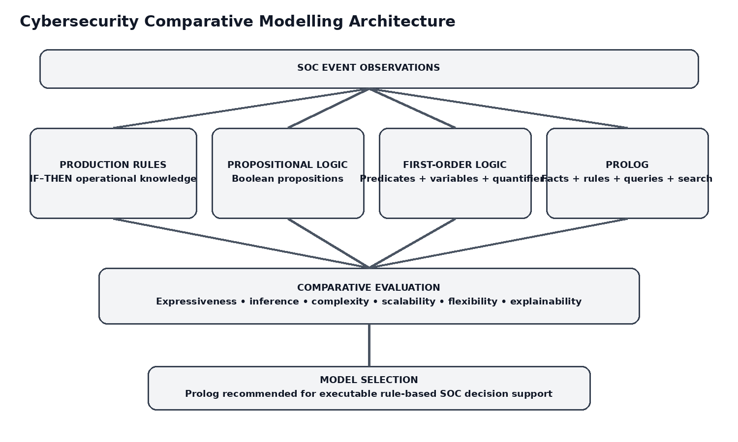
Figure 3: Comparative modelling architecture.
- All five required observations are represented consistently.
- The production-rule, propositional and FOL models derive equivalent conclusions for the main incident.
- The Prolog implementation executes queries and supports both explicit forward chaining and backward goal reasoning.
- The same rules remain explainable because each conclusion has an identifiable chain of premises.

Recommended model
Prolog is recommended as the implementation model. It offers the best balance of expressiveness, executable inference, explainability and flexibility for this rule-based SOC prototype. FOL is the strongest formal modelling layer, while production rules are the strongest human-readable operational layer. Propositional logic is useful mainly as a compact baseline for a fixed set of Boolean indicators.

Limitations
- Binary indicators do not model uncertainty, severity or event frequency.
- The knowledge base is small and manually authored.
- No live SIEM/EDR integration is included.
- Rules identify possible threat patterns rather than proving malicious activity.
- A larger deployment would need rule prioritization, provenance, conflict handling and maintenance.

Improvements
- Add time windows and frequency thresholds.
- Add asset criticality and identity context.
- Add confidence/severity scoring.
- Map rules to a larger threat taxonomy.
- Integrate structured SIEM/EDR feeds and analyst feedback.
- Generate explanation trees and preserve rule provenance.
The rubric awards full marks when results are analyzed and the most suitable approach is convincingly justified; the recommendation is therefore based on the comparison rather than simply naming a model.

10. Conclusion, References & GitHub
Conclusion: The cybersecurity threat-detection problem can be represented progressively through production rules, propositional logic, first-order logic and Prolog. Production rules make operational knowledge readable, propositional logic provides a compact fixed Boolean model, FOL adds general entities and relationships, and Prolog makes the knowledge executable with queries and search. For this SOC use case, Prolog provides the best practical balance while the other models provide useful formal and explanatory views.

GitHub repository structure
SOC-Threat-Detection-Expert-System/
├── CO5_AT3_Cybersecurity_Expert_System.pl
├── production_rules.txt
├── propositional_model.txt
├── first_order_logic_model.txt
├── test_cases/
├── screenshots/
└── README.md
Repository link: paste the actual public GitHub URL here after creating the repository. The assignment specifically requires a GitHub repository containing Prolog code, models, test cases and supporting materials.

References
- SIMATS Engineering. Assessment Tool 3: Modelling Comparative Analysis Assignment, MLA01, CO5.
- NIST. Computer Security Incident Handling Guide, Special Publication 800-61 Rev. 2.
- MITRE ATT&CK. Valid Accounts (T1078), Enterprise technique.
- SWI-Prolog Documentation. Prolog language, rules, queries and execution model.

EVALUATION RUBRICS

Criterion | Weightage (%) | Excellent | Good | Average | Poor
1. Problem Analysis and Domain Understanding | 10% | 9–10% – Clearly analyzes the real-world problem, domain entities, constraints, facts, and expected outcomes. | 7–8% – Good understanding with minor omissions. | 5–6% – Basic understanding with limited analysis. | 0–4% – Problem is unclear or poorly understood.
2. Domain Knowledge and Fact Identification | 10% | 9–10% – Identifies comprehensive and relevant facts, entities, relationships, conditions, and domain knowledge. | 7–8% – Identifies most relevant knowledge with minor gaps. | 5–6% – Basic facts and entities are identified. | 0–4% – Important domain knowledge is missing or incorrect.
3. Production Rule Modelling | 15% | 13–15% – Develops accurate, complete, consistent IF–THEN production rules that effectively represent the problem. | 10–12% – Rules are appropriate with minor errors or omissions. | 7–9% – Basic rules are developed but several are incomplete or unclear. | 0–6% – Rules are largely incorrect, incomplete, or inappropriate.
4. Propositional Logic Modelling | 10% | 9–10% – Correctly represents domain knowledge using propositions, logical connectives, and valid inference statements. | 7–8% – Good propositional representation with minor errors. | 5–6% – Basic representation with limited logical formulation. | 0–4% – Representation is incorrect or incomplete.
5. First-Order Logic Modelling | 15% | 13–15% – Accurately models entities, relationships, properties, variables, predicates, and quantifiers with valid FOL statements. | 10–12% – Good FOL model with minor errors or omissions. | 7–9% – Basic FOL representation with limited relationships or incorrect usage of some constructs. | 0–6% – FOL model is largely incorrect or missing.
6. Prolog Modelling and Implementation | 15% | 13–15% – Successfully converts the knowledge model into Prolog facts, rules, predicates, and queries with correct outputs. | 10–12% – Functional Prolog implementation with minor technical issues. | 7–9% – Basic implementation works but has limited functionality. | 0–6% – Implementation is incomplete or non-functional.
7. Forward and Backward Chaining Demonstration | 10% | 9–10% – Clearly demonstrates both forward and backward chaining with correct inference sequences and conclusions. | 7–8% – Both mechanisms are demonstrated with minor gaps. | 5–6% – Basic demonstration with limited reasoning explanation. | 0–4% – Chaining is absent or incorrectly demonstrated.
8. Comparative Analysis of Modelling Approaches | 10% | 9–10% – Provides a detailed and insightful comparison based on expressiveness, inference, complexity, scalability, flexibility, and explainability. | 7–8% – Provides a meaningful comparison using appropriate parameters. | 5–6% – Basic comparison with limited criteria or analysis. | 0–4% – Little or no meaningful comparison.
9. Results, Discussion and Model Selection | 3% | 3% – Clearly analyzes results and convincingly justifies the most suitable approach for the selected problem. | 2% – Provides good analysis and reasonable justification. | 1% – Basic discussion with limited justification. | 0% – No meaningful analysis or justification.
10. Documentation, GitHub Repository and Presentation | 2% | 2% – Report is complete and well structured, GitHub repository is organized, and presentation is professional. | 1.5% – Good documentation and presentation with minor issues. | 1% – Basic documentation with some omissions. | 0% – Poor documentation, missing repository, or inadequate presentation.
Total | 100%

